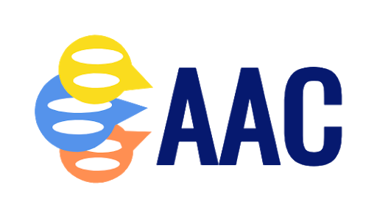
AAC Collaborative Supports: Snapshot

Student’s Name: | Grade/Age:
School/Classroom: | Date:
AAC Needs Assessment Date: | Completed by:
Student’s Current User Level (pick more than one if “bridging”): Emergent Entry Intermediate Advanced

Multimodal communication and strategies being targeted (check all that apply, briefly describe)
Aided Language Stimulation: | Body Language: whole body gestures facial expressions | Choice-making: | Encoding:
Eye gaze: | Gestures: | Modeling/Prompting: | Partner-assisted scanning:
Proxemics: | Social Scripts: | Spelling: | Vocalizations & Verbal approximations:

Communication tools (No-Tech and Technology) being used (check all that apply, briefly describe):
Name of tool:  Describe: | Language is represented by:  Student accesses system by:
Part of classroom “toolkit”  Purchased for Student | Funding Source:  Parent - (date: )  School District - (date: )  Medically-based funding - (date: )
Name of tool:  Describe: | Language is represented by:  Student accesses system by:
Part of classroom “toolkit”  Purchased for Student | Funding Source:  Parent - (date: )  School District - (date: )  Medically-based funding - (date: )
Name of tool:  Describe: | Language is represented by:  Student accesses system by:
Part of classroom “toolkit”  Purchased for Student | Funding Source:  Parent - (date: )  School District - (date: )  Medically-based funding - (date: )

Device Management:
Passwords:
Back-Up Information:
Restrictions (e.g. guided access):

Goals/Skills we are developing:
Social/Strategic Competence | Linguistic Competence | Operational Competence
# : | # : | # :
# : | # : | # :

