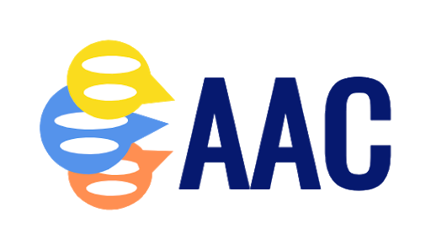
AAC Collaborative Supports: Snapshot
Student’s Name: | Grade/Age:
School/Classroom: | Date:
AAC Needs Assessment Date: | Completed by:
Student’s Current Communicator Level Profile (pick more than one if “bridging”): Emergent Entry Intermediate Advanced

Multimodal communication and strategies being targeted (check all that apply, briefly describe)
Body Language:  Whole Body/Proxemics | Body Language:  Facial Expressions | Body Language:  Gestures | Vocalizations & Verbal Approximations:
Eye gaze: | Choice-making: | Modeling/Prompting: | Social Scripts:
Aided Language Modeling: | Partner-Assisted Scanning: | Spelling: | Encoding:

Communication tools (No-Tech and Technology) being used (check all that apply, briefly describe):
Name of tool:  Describe: | Language is represented by:  Student accesses system by:
Part of classroom “toolkit”  Purchased for student | Funding Source:  Parent - (date: )  School District - (date: )  Medically-based funding - (date: )
Name of tool:  Describe: | Language is represented by:  Student accesses system by:
Part of classroom “toolkit”  Purchased for student | Funding Source:  Parent - (date: )  School District - (date: )  Medically-based funding - (date: )
Name of tool:  Describe: | Language is represented by:  Student accesses system by:
Part of classroom “toolkit”  Purchased for student | Funding Source:  Parent - (date: )  School District - (date: )  Medically-based funding - (date: )

Device Management:
Passwords:
Back-Up Information:
Restrictions (e.g. guided access):

Goals/Skills we are developing:
Social/Strategic Competence | Linguistic Competence | Operational Competence
# : | # : | # :
# : | # : | # :

