Student Name: Date:
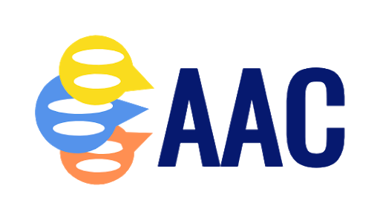
 | Social/Strategic Competence  * Knowledge, judgment and skill in the social-relational aspects of communication  * Adaptive or coping strategies to use when communication breakdowns occur | Linguistic Competence  * Understanding and expressing language; Functional mastery of the symbol system or linguistic code for representing language | Operational Competence  * Knowledge of operational and maintenance aspects of device or system
Phase 1 - Emergent | Orients & attends speaker  Uses nonverbal means to get someone’s attention  Maintains eye contact with others appropriately (not rated for student’s with VI)  Uses a consistent gesture or vocalization to signal pleasure/ displeasure  Uses a consistent communication behavior to affirm or reject choices | Indicates comprehension of spoken names of people and objects in non-verbal ways, like reaching for, pointing to, looking at, picking up or moving  Starting to follow directions with routine and familiar activities  Recognizes objects when named by partner | Appropriate seating that provides proper support for access (if applicable)  [for student’s with physical access issues:]  Has one-two identified switch “sites” for developing access skills  Shows purposeful motor movement to activate a switch (initiate movement, inhibit interfering motor patterns)
Phase 2 – Entry | Consistently confirms choices  Consistently responds to partner’s initiations  Knows and acts on communication opportunities  Asks questions of other group members  Shares information when requested of other group members  Comments on own or other group members information  Gives directions for group activities  Uses vocabulary to effectively open, maintain and close an interaction | Effectively uses a low-technology communication strategy (e.g. partner assisted scanning, eye gaze board, communication board) to make choices  Effectively uses a low-technology communication strategy to answer forced choice questions  Recognizes symbols for nouns/labels  Recognizes symbols for transparent verbs/action words  Recognizes symbols for adjectives/ descriptor words  Uses symbols for nouns/labels  Uses symbols for transparent verbs/action words  Uses symbols for adjectives/descriptor words | [for student’s with physical access issues:]  Eye gazes to symbol from arrays of 2-4  Activates a switch contingent on a  auditory or visual cue with 80% accuracy,  within 10 seconds of cue  Hits switch to start and stop a scan cycle  Step scans through items  Automatic scans through items  auditory/visual scanning  visual scan alone  auditory scan alone  [direct selection]  Can select symbols from arrays of 2 – 4  Can select symbols from arrays of 5 – 10  Can select symbols from arrays of 11- 20  Can select symbols from arrays of 21+  Demonstrates familiarity with a variety of visual/auditory arrays for familiar routines and activities (# of arrays/boards )  Accesses pre-stored vocabulary/messages that are appropriate to the activity or context
 | Social/Strategic Competence  * Knowledge, judgment and skill in the social-relational aspects of communication  * Adaptive or coping strategies to use when communication breakdowns occur | Linguistic Competence  * Understanding and expressing language; Functional mastery of the symbol system or linguistic code for representing language | Operational Competence  * Knowledge of operational and maintenance aspects of device or system
Phase 3 - Intermediate | Communicates novel thoughts and ideas using non-verbal means of communication  Exchanges turns appropriately in a group  Transitions smoothly to other topics of conversation  Changes communication strategies depending on social and physical environment  Recognizes communication breakdowns  Uses basic spelling strategies (e.g. starts with) to cue partner | Responds to and generates a variety of question forms  Categorizes symbols according to basic – superordinate categories  Recognizes symbols for location words  Recognizes symbols for opaque verbs/action words  Recognizes symbols for pronouns and prepositions  Recognizes symbols for question words  Uses symbols for location words  Uses symbols for opaque verbs/action words  Uses symbols for pronouns and prepositions  Uses symbols for question words | Accesses vocabulary in a timely fashion consistent with abilities  Uses encoding strategies on eye gaze system, if appropriate  Navigates to the appropriate page in flipbook and/or dynamic screen device  Turns device on/off  Changes volume as needed  Indicate when device needs charging
Phase 4 – Advanced | Explains reasons or causes  Can make reference to a wide variety of topics  Asks for clarification  Maintains an equal balance of conversational turns with partner(s)  Alerts partner when experiencing communication breakdowns  Instructs unfamiliar partners regarding AAC system and strategies  Makes oneself understood when misunderstood | Categorizes symbols according to grammatical categories  Uses symbols to construct 2 -3 core word messages (subject-verb-object)  Uses symbols to construct core word messages including prepositions and adjectives  Uses symbols to construct core word messages including articles and verb forms  Uses spelling to generate novel words | Formulates sequences (symbols or words) to recall previously stored messages  Uses rate enhancement features available in his/her system  Indicates need for additional vocabulary  Independently programs/stores vocabulary  Instruct caregivers in need for repairs and maintenance

