An AAC needs assessment assists the educational team in determining whether a student’s current systems of communication (including any aided supports) are meeting the student’s needs for showing what they know or understand; building independence; and building relationships or social connection. If additional supports are indicated, the process includes evaluating the underlying skills or factors that impact the identification and selection of appropriate communication strategies and tools in order for the team to discuss potential solutions and next steps.

Student Information:
Name: | Birthdate: | Age:
School District: | School of Attendance:
Date of Report: | Assessor:

Primary participants for reviewing/determining AAC supports:
Name(s): | Role:
 | Parent(s)/Guardian(s)

RECORDS REVIEWED

BACKGROUND INFORMATION

PURPOSE/CURRENT NEED FOR THIS ASSESSMENT

THIS ASSESSMENT INCLUDES:
- A summary of ’s current communication strategies
- A description of any aided supports currently available
- A summary of current skills as they relate to the use of AAC supports
- Recommendations for the IEP team to consider

All tools/activities used were valid for the specific purpose for which they were used and were selected as most appropriate when considering the student’s cultural and individual needs, and language and cognitive levels. No standardized tests were administered as assistive technology (AAC) is not an evaluation for eligibility (see description above). Information gathered will be reviewed with the educational team in order to make team-based priorities and decisions.

PHASE 1: HOW DOES THE STUDENT CURRENTLY COMMUNICATE?
Communication sampling tool:

Observation/settings:

Describe the student’s current range of communication behaviors (or means):

What does the student communicate for and about (or communication functions):

Describe verbal behavior:

Current use of aided communication tools:

ARE STUDENT’S CURRENT SYSTEMS (including vocalization/verbalization, nonverbal behavior and any aided systems currently in place) OF COMMUNICATION MEETING HIS/HER NEEDS?
YES
NO

Summary:

PHASE 2: OBSERVATIONS/DATA COLLECTION OF STUDENT’S CURRENT SKILL LEVELS (related to using aided communication tools)
Data gathering tools:
Summary of mobility/positioning:
Summary of access skills:
Overall Motor-Access considerations for potential communication tool(s):

Data gathering tools:
Summary of vision/hearing/tactile:
Overall Sensory-Perceptual considerations for potential communication tool(s):

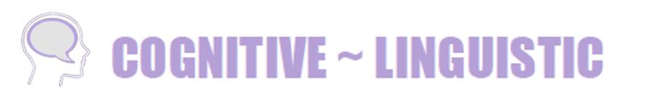
Data gathering tools:
Summary of general cognitive/language skills:
Summary of symbolic skills:
Summary of literacy skills:
Overall Cognitive-Linguistic considerations for potential communication tool(s):

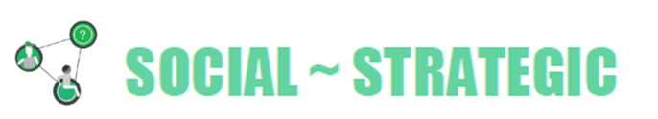
Data gathering tools:
Motivation to communicate:
Partner considerations:
Summary of social skills:
Summary of strategic skills:
Overall Social-Strategic considerations for potential communication tool(s):

SUMMARY:
Skills student currently demonstrates: Based on the information gathered, demonstrates the characteristics of having an ‘ Level Communicator Profile’, with the following description: .
What outcomes are we working toward?: Our goal for all individuals with complex communication needs is to support them in developing the skills needed to participate fully in all aspects of life including expressing wants and needs, exchanging information, building social closeness and participating effectively in social routines. In order to support in moving closer to achieving these long-term outcomes, the following priorities are identified for current skill building:

RECOMMENDATIONS:
- Recommendations for STRATEGIES to support current priorities for skill development:
At this time, would benefit from continuing to use multimodal communication which will allow to build language skills through increasing the range of communication forms and functions has access to. The focus of using a multimodal approach is to increase meaningful and active participation in the learning environment and building relationships and social connection with peers, staff and family.
Specific multimodal and communication partner strategies to consider:
- Recommendations for TOOLS to support current priorities for skill development:
would benefit from a tool/s that has the following critical features:

Examples of tools that can meet ’s current needs include:
Tools
Description

NEXT STEPS:
The team may consider and prioritize tool(s) for exploration or trials. It is recommended that the team re-convene following any exploration or trial to review outcomes and make final recommendations. At that time, the team may want to consider specific IEP goals/objectives to support ’s skill development (e.g. across the areas of social-strategic, linguistic, and/or operational competencies).

In order to build shared beliefs, responsibilities and priorities for supporting in obtaining these outcomes, the team may want to consider using one or more of the following collaborative team processes once a system is in place:
AAC Snapshot: A shared summary of information that all team members need to know and understand as we work together to “move students forward” with communication competence using aided tools.
AAC Roles and Responsibilities: A plan for defining “who is doing what” when it comes to managing all of the support needed for a student with a more robust, aided communication system.
Communication Access Plan: A team-based collaborative process to identify current challenges, consider current settings and supports, and identify priorities for taking small steps towards implementing successful strategies to support skill development and communication competence for the student.

Please feel free to contact me with any questions or concerns. I look forward to discussing these recommendations and supporting and team in further developing communication skills and competence.

